**A Blockchain that attracts International Diamond Buyers**

Blockchain technology enables reliable records to be kept of all work and approval steps in the process of procurement, contracting, managing tenders and disbursing funds when implementing a project. With the aim of making the use of public funds transparent and verifiable, Germany’s KfW Development Bank teamed up with the KfW Digital Office to develop the TruBudget (Trusted Budget Expenditure Regime) software application which is based on this innovative technology. All of the parties involved can collaborate on this platform and track who made what changes. The blockchain technology not only enables greater transparency, even more importantly, it prevents retroactive or unauthorised changes. This minimises the risk that funds are misused by the institutions that receive the disbursements.

"One of the biggest obstacles to economic development is the mismanagement of public funding. It also jeopardises the effectiveness of Financial Cooperation on a regular basis. KfW's TruBudget is an innovative digital application from which other development banks can also benefit. This software makes Germany a global pioneer in the use of digital solutions to alleviate poverty," said Dr Norbert Kloppenburg, member of the Executive Board of KfW Group.

The funds in public budgets in developing countries are at risk of being misappropriated, instead of being used to benefit the common good (e.g. for hospitals and schools). International donors respond to these risks and the weak implementation capacity in the partner countries by setting up parallel structures. But the associated transaction costs of this strategy are very high for both sides. Moreover, by circumventing the systems of the partner institutions in the respective developing or emerging countries, the donors also make it more difficult to achieve their aim of enabling the partner countries to plan and implement projects on their own.

In a EUR 1 million pilot phase financed by BMZ, the existing software prototype will first be tested with ongoing investment projects and undergo further development. KfW currently evaluates a pilot phase with several countries in Africa.

**Appendix A – KfW Bank TruBudget Screen Shots**

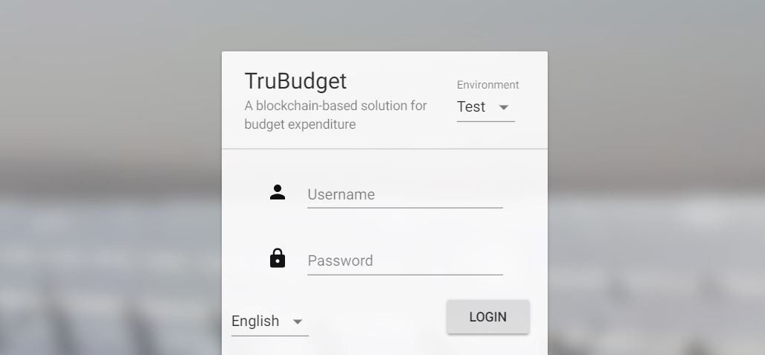

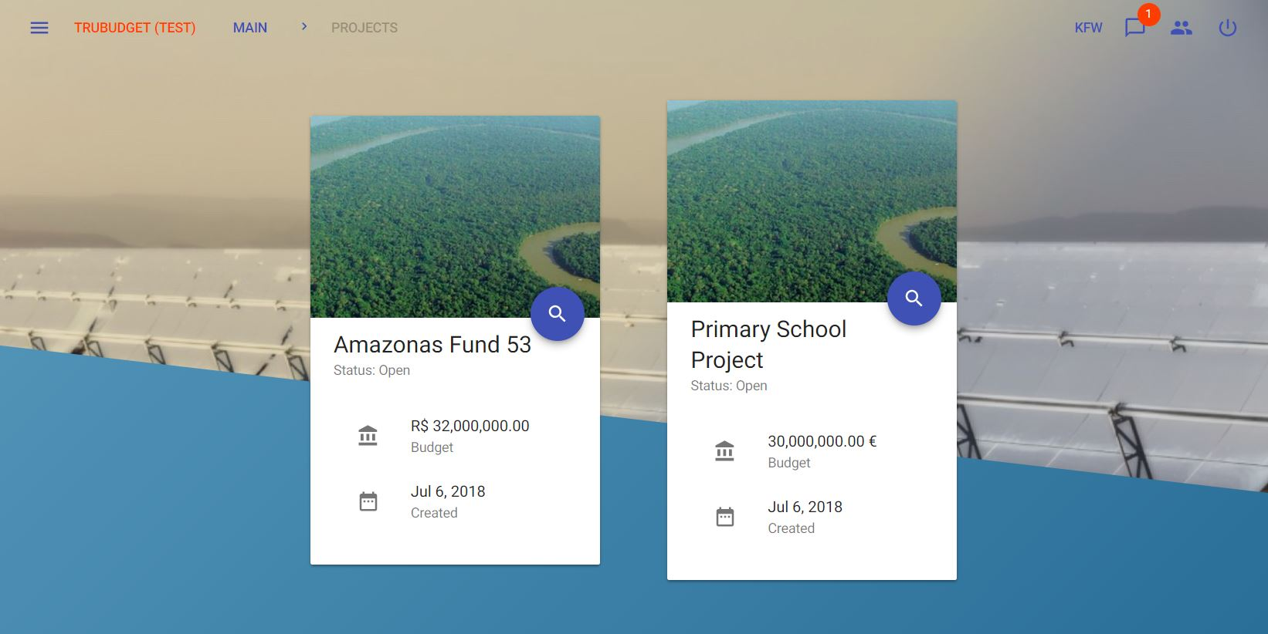

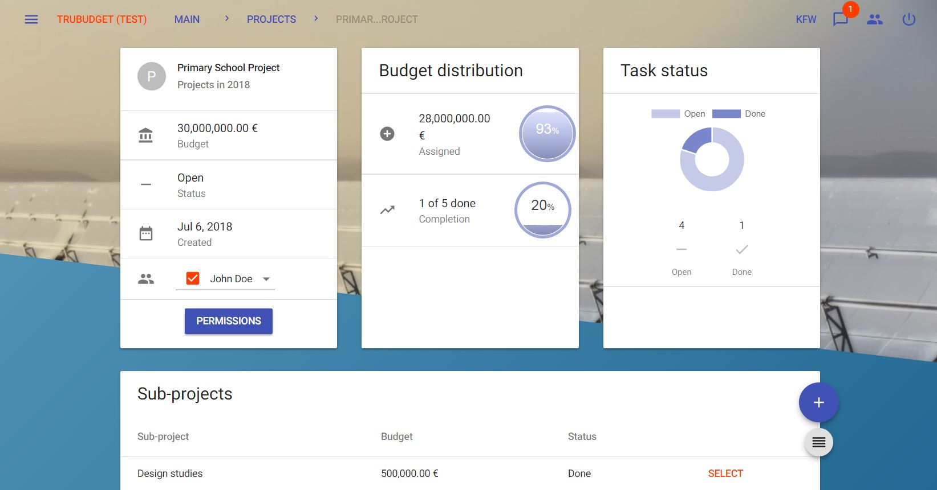

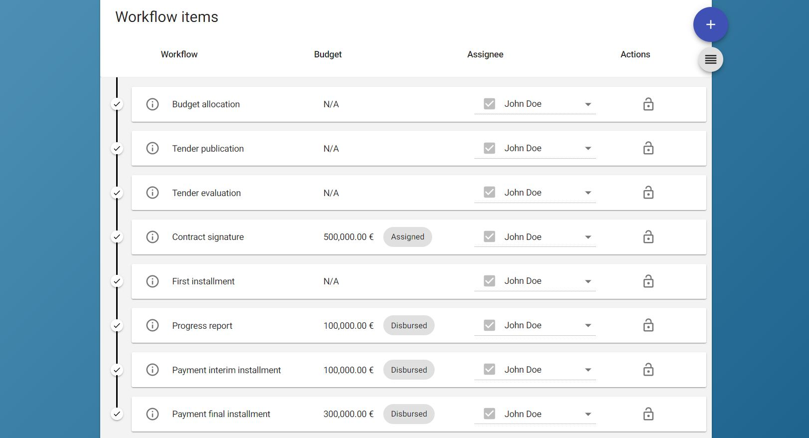

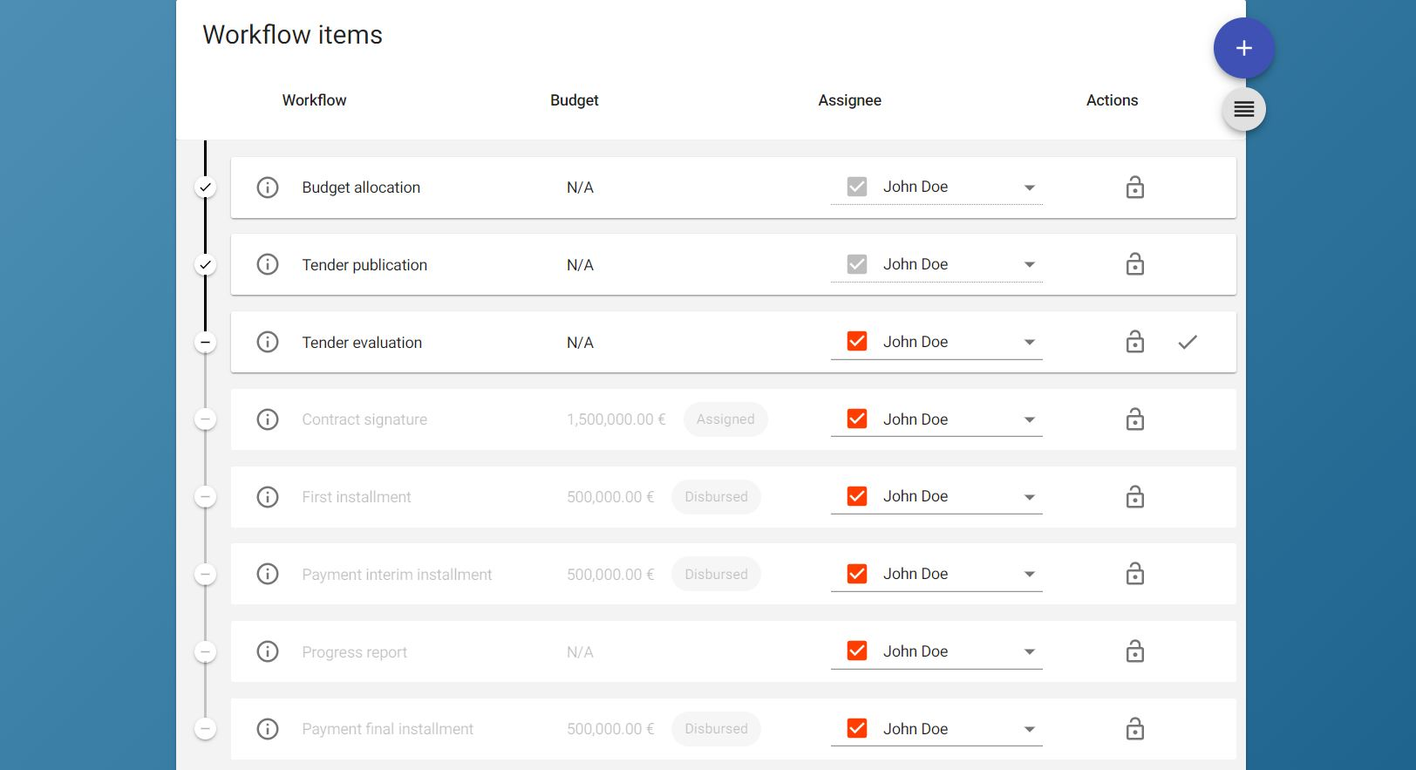

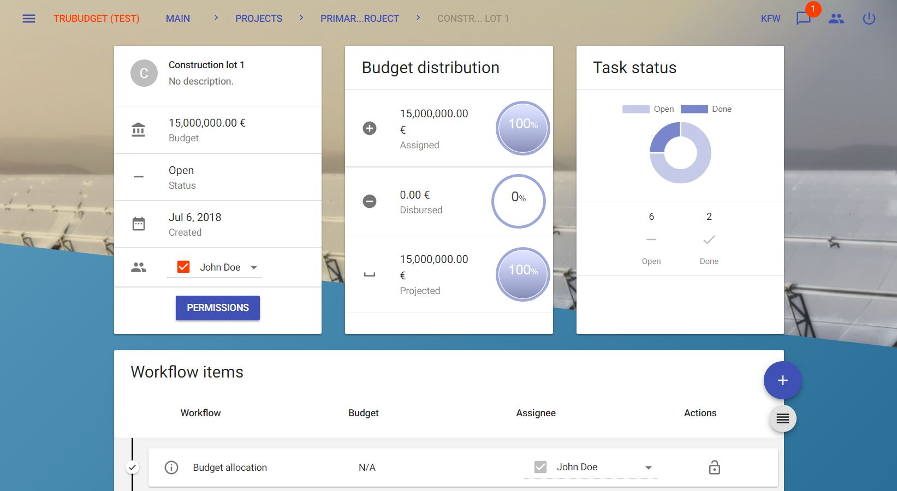

**De Beers Blockchain Delivery Schedule**

|  |  |  |
| --- | --- | --- |
|  |  |  |
| Proposal – Ministry of Finance | 15 Days | 25 December |
| * De Beers TRACR Blockchain | 15 Days | David |
| * KfW Bank - TruBudget | 15 Days | Beauty |
| * Surveillance Technology | 15 Days | Rayner |
| Computer Simulation [GemPrint API + Blockchain + Tender + Contracts] | 21 Days | 31 December |
| Great Dyke Website [<www.2045.com>] | 21 Days | 31 December |
| Great Dyke Company + PRAZ Registration + VAT Clearance | 21 Days | 31 December |
| KfW Bank – TruBudget Proposal Submission + Communication | 10 days | 2 – 15 January |
| De Beers Proposal Submission+ Communication | 10 days | 2 – 15 January |
| Zimbabwe Ministry of Finance Proposal Submission + Communication |  | 11 January |